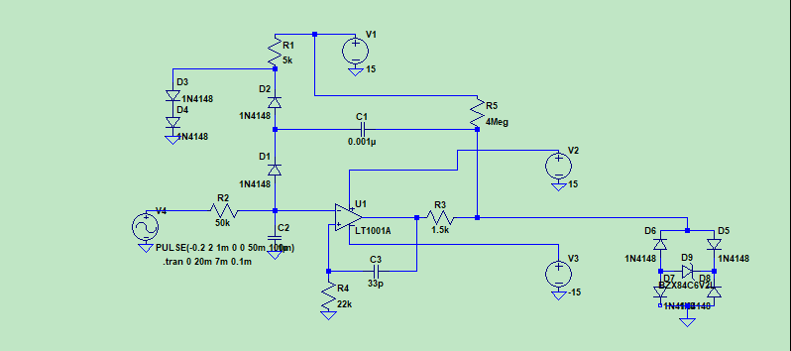

Given circuit is Voltage to Frequency converter originally designed by Bob Pease
- Basic operation is to convert input applied dc Voltage into Output pulse with frequency related which is function of input dc Voltage

- First of all, lets assume that negative input of op-amp sitting on small negative voltage, and positive input of op-amp is on zero voltage. Thus we have an +15V at op-amp output.
- Now lets apply some positive input voltage, then our C2 cap is starts charging. When its voltage rises above zero, output of U1 will saturate toward -15V, and the overall output will be pulled down to approximately -7.5V. Thus the right plate of C1 is goes from 7.5 to -7.5 V, giving us -15V change. However at the left plate voltage of C1 left unchanged, due to D1 and to only small amount of positive voltage at the C2. Thus around C1*(-15V) charge is pulled from C2 through D1.
- At that moment we can see usefulness of C3 cap. When U1 output is at -15V, C2 will starts discharging, however without C3, positive input of U1 always remain zero V, thus C2 can only discharge to zero, but we need to discharge C2 to voltage below zero to start the new cycle.
Now lets add C3. When U1 output jumps to -15V, positive input of U1 will fall to voltage below zero. This effect gives time for C2 to discharge to voltage under zero.
- As we can see when we increase the input dc Voltage C2 will charge up more faster toward zero. Thus giving us faster negative pulse at the output

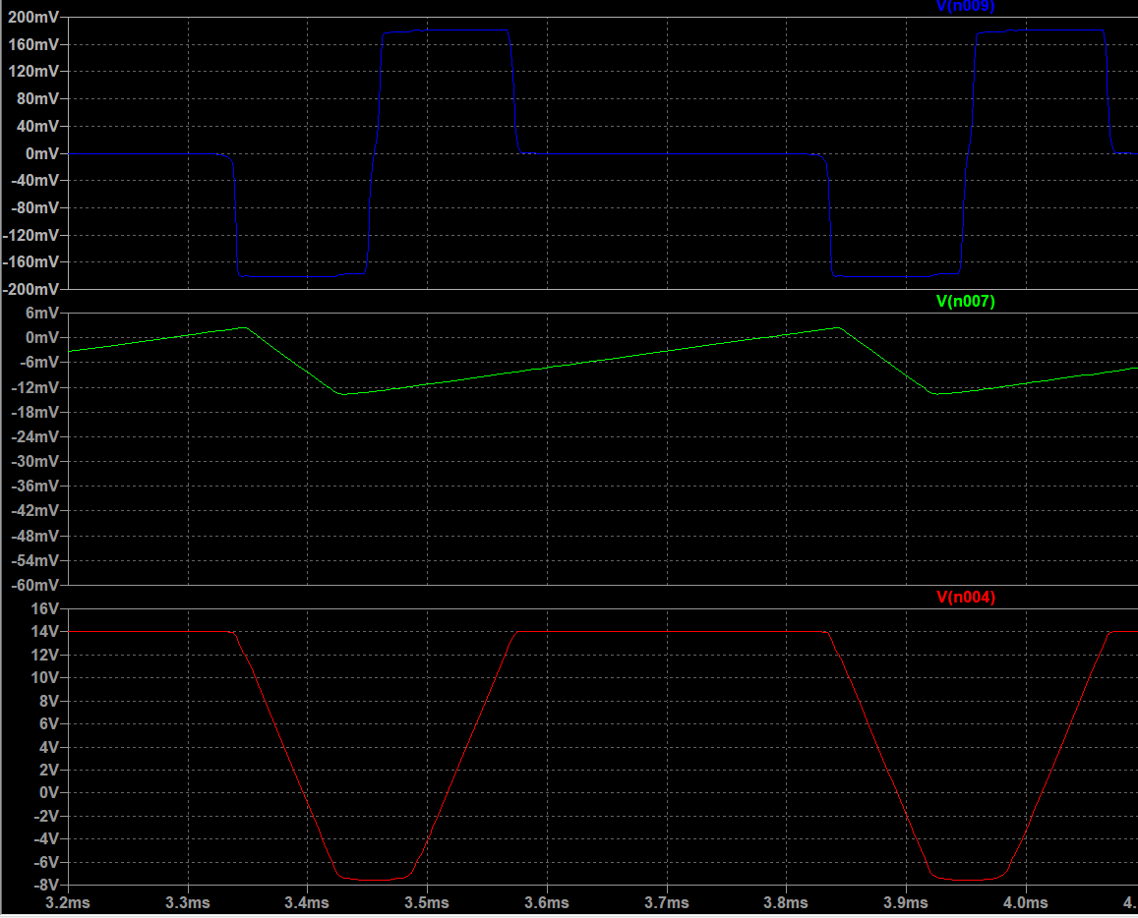

Blue - V+
Green - V-
Red - Vout(U1)

As we can see from the graph C3 cap will create negative going pulse at the V+, which helps V- to discharge down to -12mV, which is around -15*C1/C2 = -15*0.001u/1u = -15mV.

